Long term Plan English Year 1
Autumn 1 | Autumn 2 | Spring 1 | Spring 2 | Summer 1 | Summer 2
Learning Journey 1 | Learning Journey 1 | Learning Journey 1 | Learning Journey 1 | Learning Journey 1 | Learning Journey 1
Text:  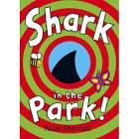  Shark in the Park  Nick Sharratt  Outcome: A list of everything seen through a telescope  Purpose: inform  Audience: To inform the Dad within the story  Form: List writing  Viewpoint: 1st person from the perspective of Timothy Pope  Powerful Poetry: Shark in the Dark – Nick Sharratt | Text:  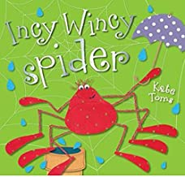  Incy Wincy Spider  Kate Toms  Outcome: A recount from the spiders perspective  Purpose: inform  Audience: Share with nursery children  Form: A recount  Viewpoint: 1st person  Powerful Poetry: Itsy Bitsy Spider (Nursery Rhyme) | Text:  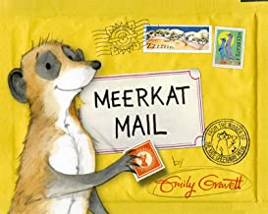  Meerkat Mail  Emily Gravett  Outcome: Travel brochure  Purpose: inform  Audience: Children ; Travel brochures to be published in the role play area  Form: Leaflet  Viewpoint: second person  Powerful Poetry: Continents of the World  -A.A.Anderson | Text:  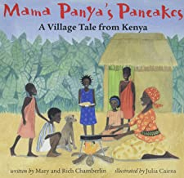  Mama Panya’s Pancakes  Mary and Rich Chamberlain  Outcome: To create a recount  Purpose: inform  Audience: to share in assembly to other children  Form: Recount  Viewpoint: third person  Powerful Poetry: Rumble in the Jungle – Giles Andreae | Text: 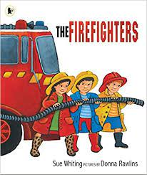Fire Fighters  Sue Witting  Outcome: Awareness poster  Purpose: inform  Audience: Share with firefighters when they visit  Form: poster  Viewpoint: second person  Powerful Poetry: London’s burning | Text:  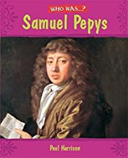  Samuel Pepys  Paul Harris  Outcome: A recount from the perspective from Samuel Pepys as the original diary has gone missing.  Purpose: inform  Audience: audience ;send a copy to London History Museum  Form: Diary entry  Viewpoint: 1st person  Powerful Poetry:  Diary Entry by Matt Burgett
Learning Journey 2 | Learning Journey 2 | Learning Journey 2 | Learning Journey 2 | Learning Journey 2 | Learning Journey 2
Text:  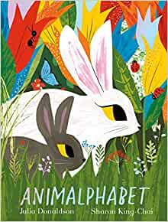  Animal Alphabet  Julia Donaldson  Outcome: An animal fact file with excellent adjectives  Purpose: entertain/inform  Audience: To create class fact file books for the Infant library  Form: Fact file  Viewpoint: Third person as an animal researcher  Powerful Poetry: Bug Parade – Zaro Weil | Text:  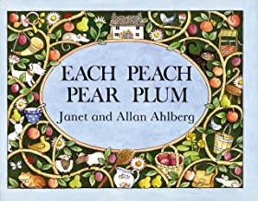  Each Peach Pear Plum  Janet and Allan Ahlberg  Outcome: A retelling of the narrative  Purpose: entertain  Audience: Publish a book with illustrations for Janet and Allan Ahlberg  Form: story writing  Viewpoint: first person  Powerful Poetry: Tom Thumb (nursery rhyme) | Text:  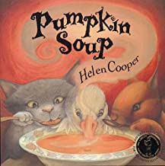  Pumpkin Soup  Helen Coper  Outcome: A set of instructions to create pumpkin soup  Purpose: inform  Audience: Parent’s to join in class to make soup  Form: instructions  Viewpoint: Third Person  Powerful Poetry:  Painting on Toast – Caleb Brown | Text:  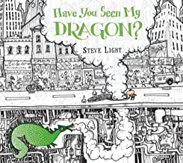  Have you seen my dragon?  Steve Light  Outcome: A missing poster  Purpose: entertain  Audience: to be displayed in infant windows to raise awareness to other children  Form: a poster  Viewpoint: third person  Powerful Poetry:  Where the fairies are – David Harner | Text:  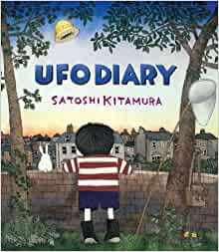  UFO Diary  Satoshi Kitamura  Outcome: A recount of the day a mysterious UFO appeared on our field  Purpose: inform  Audience: Community – Newspaper reports to be sent home  Form: a newspaper report  Viewpoint: third person  Powerful Poetry:  The Rubbish Tip Alien - Pie Corbett | Text:  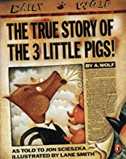  The True Story of the Three Little Pigs  Jon Scieszka  Outcome: To invent a new ending that challenges the stereotypes of the wolf  Purpose: entertain  Audience: to share a copy with new year 2 teachers.  Form: Story writing  Viewpoint: 1st person  Powerful Poetry:  The Big Bad Wolf Speaks Out – Elizabeth Bennett
Learning Journey 3 | Learning Journey 3 | Learning Journey 3 | Learning Journey 3 | Learning Journey 3 | Learning Journey 3
Text:  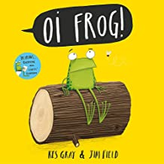  Oi Frog  Kes Gray and Jim Field  Outcome: Frog inspired poetry  Purpose: Entertain  Audience: To be video recorded and shared with parents on Tapestry  Form: Poem with rhyming couplets  Viewpoint: Third Person  Powerful Poetry:  Nature trail – Benjamin Zephaniah | Text:  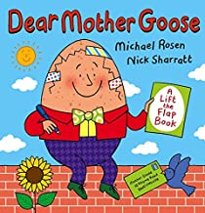  Dear Mother Goose  Michael Rosen and Nick Sharratt  Outcome: A letter from mother goose  Purpose: inform  Audience: Letter to be written to Incy Wincy spider  Form: letter  Viewpoint: first person  Powerful Poetry:  Sing a song of sixpence by Mother Goose | Text:  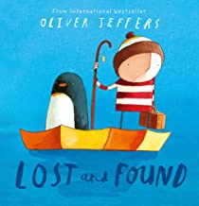  Lost and Found  Oliver Jeffers  Outcome: A retelling of the narrative  Purpose: entertain  Audience: Share stories with EY children  Form: story writing  Viewpoint: Third Person  Powerful Poetry:  The sail Boat by Anonymous | Text:  Have you seen my dragon?  Steve Light  Outcome: Dragon Poetry  Purpose: entertain  Audience: Perform to year 2 Children  Form: Poetry with repeated phrases  Viewpoint: first person  Powerful Poetry:  My New pet by Mrs Malonery |  | :

