Long term Plan English - Year 2
Autumn 1 | Autumn 2 | Spring 1 | Spring 2/ Summer 1 | Summer 2
Learning Journey 1 | Learning Journey 1 | Learning Journey 1 | Learning Journey 1 | Learning Journey 1
Text:  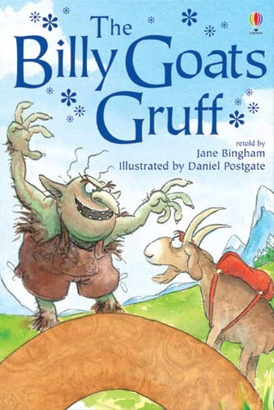  The Billy Goats Gruff  Jane Bingham  Outcome: A wanted poster for the evil troll  Purpose: entertain  Audience: The goats in the story trying to locate him  Form: A wanted poster with clear description  Viewpoint: 2nd person  Powerful Poetry: | Text:  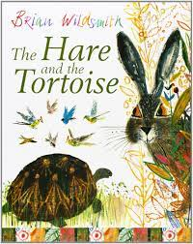  The Hare and the Tortoise  Brian Wildsmith  Outcome: A recount from the news reporter at the race.  Purpose: inform  Audience: Children – place newspaper reports in windows around school.  Form: A newspaper recound  Viewpoint: third person  Powerful Poetry: | Text:  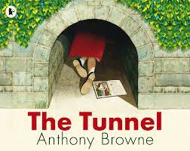  The Tunnel  Anthony Browne  Outcome: An argument on whether Rose should travel through the tunnel  Purpose: persuade  Audience: Rose from the story  Form: conscience alley  advice slip for Rose  Viewpoint: Second person  Powerful Poetry: | Text:  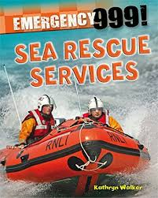  A range of non-fiction rescue services texts  Outcome: To create an acrostic poem focussed on rescue services.  Purpose: entertain  Audience: to share with the RNLI on their visit to school  Form: acrostic poem  Viewpoint: third person  Powerful Poetry: The Sea – John Foster | 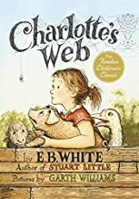  Charlotte’s Web  E.B.White  Outcome: Some pages of E.B white’s classic novel have been burnt – we must help by writing the resolution to the problem  Purpose: entertain  Audience: to send to E.B White to help solve her dilemma  Form: narrative writing.  Viewpoint: third person  Powerful Poetry: Mini- Who – Jillian Harker
Learning Journey 2 | Learning Journey 2 | Learning Journey 2 | Learning Journey 2 | Learning Journey 2
Text:  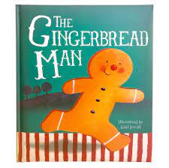  The Gingerbread Man  Gail Yerrill  Outcome: instructions to create gingerbread  Purpose: inform  Audience: The little old woman has lost her recipe. We need to make her a new one!  Form: Sequenced instructions  Viewpoint: Second person  Powerful Poetry: | Text:  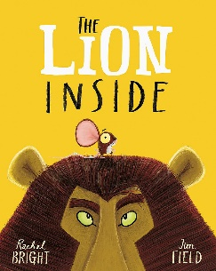  The Lion Inside  Rachel Bright and Jim Field  Outcome: A letter  Purpose: inform  Audience: The lion in the story – we need some answers!  Form: Letter writing  Viewpoint: first person  Powerful Poetry: | Text:  The Tunnel  Anthony Browne  Outcome: Published stories with an alternative ending  Purpose: entertain  Audience: Anthony Browne can’t decide what happens through the tunnel – we must help him!  Parents – shared with parents at our story telling café!  Form: narrative writing  Viewpoint: Third person  Powerful Poetry: Continents of the World  -A.A.Anderson | Text:  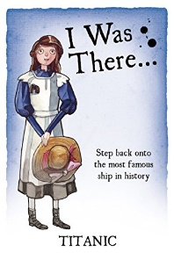  I was there Titanic  Outcome: A newspaper report as the Titanic set sail on its maiden voyage  Purpose: inform  Audience: Copies to be sent to the Sea City Museum  Form: Newspaper report (recount.)  Viewpoint: Third person  Powerful Poetry:  There are Big Waves  Eleanor Farjeon | Text:  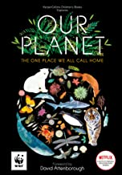  Our Planet  David Attenborough  Outcome: A persuasive letter to the council – they want to destroy and use our woods  Purpose: persuade/inform  Audience: Hampshire County Council (Mr Cycle.)  Form: persuasive letter  Viewpoint: 1st person  Powerful Poetry:
Learning Journey 3 | Learning Journey 3 | Learning Journey 3 | Learning Journey 3 | Learning Journey 3
Text:  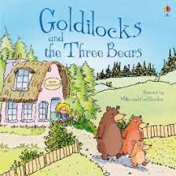  Goldilocks and the Three Bears  Outcome: A retelling of the story  Purpose: Entertain  Audience: Children – we need a new exciting version in our library.  Form: Narrative  Viewpoint: Third Person  Powerful Poetry: | Text:  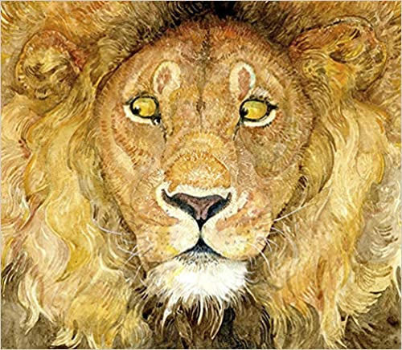  The Lion and the Mouse  Jerry Pinkney  Outcome: Retell the wordless fable  Purpose: entertain  Audience: Jerry Pinkney – Jerry needs some words to support his retelling of the story.  Form: narrative story – published using book creator  Viewpoint: Third Person  Powerful Poetry: | Text:  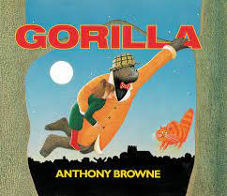  Gorilla  Anthony Browne  Outcome: A letter  Purpose: inform  Audience: A letter to Dad in the story informing him of your feelings.  Form: letter  Viewpoint: first person.  Powerful Poetry: | Text:  I was there Titanic  Outcome: Diary entry from the perspective of Daisy  Purpose: inform  Audience: Daisy’s siblings in America  Form: A recount of the day the alarms sounded and danger struck  Viewpoint: first person  Powerful Poetry:  Read All About It – Titanic newspaper inspire poem | 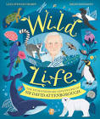  Wildlife –  The adventures of David Attenborough  Outcome: A news bulletin about the proposed use of our woods  Purpose: inform  Audience: All children at Wildground  Form: News bulletin recorded on i-pads.  Viewpoint: third person.  Powerful Poetry:

