Long term Plan English Year 3
Autumn 1  Scrapheap Challenge | Autumn 2  Me and My Shadow | Spring 1  The Mystery of Stonehenge | Spring 2  Rotten Romans | Summer 1  A land down under-Australia | Summer 2  Amazon adventure
Learning Journey 1 | Learning Journey 1 | Learning Journey 1 | Learning Journey 1 | Learning Journey 1 | Learning Journey 1
Text: The Tin Forest by Helen Ward  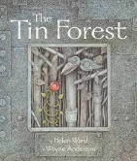  Outcome: A description of the forest setting during the day and the night, conveying different viewpoints  Purpose: To describe  Audience: Visitors to the forest  Form: Narrative setting description | Text:  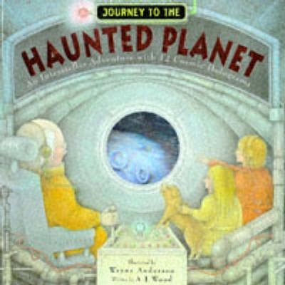  Journey to the haunted planet By A.J. Wood  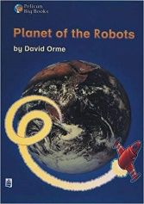  Planet of the Robots By David Orme  Outcome:  Purpose: To entertain  Audience: Marvel publishers  Form: Story and comics: Science fiction narrative  Viewpoint: 3rd person | Text:  Dear March-Come in by Emily Dickenson  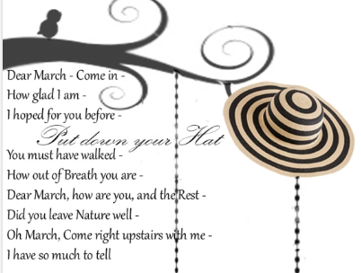  Outcome: Poem  Dear …..  Purpose: To entertain  Audience: Wide audience  Form: Poem  Viewpoint: 1st person | 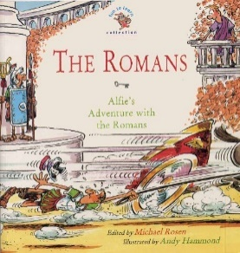  Text: The Romans – Alfie’s Adventure with the Romans  Outcome: Port key story  Purpose: to entertain  Audience: children  Form: Story  Viewpoint: 3rd person | Text: The Koala Who Could  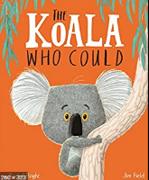  Outcome: performance poetry  Purpose: to entertain  Audience: parents and peers  Form: poetry  Viewpoint: 3rd person | Text: The Great Kapok Tree  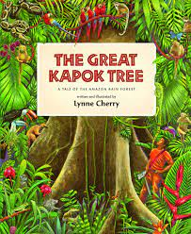  Outcome: letter to the factory owner from Senor  Purpose: to persuade  Audience: the factory owner  Form: formal persuasive letter  Viewpoint: 1st person
Learning Journey 2 | Learning Journey 2 | Learning Journey 2 | Learning Journey 2 | Learning Journey 2 | Learning Journey 2
Text:  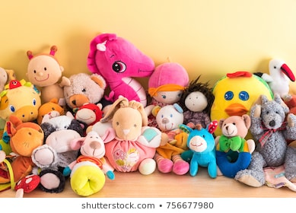  A selection of poetry about toys  Outcome: Poem in a similar style  Purpose: To entertain  Audience: Parents and library users (class book of poems)  Form: Poetry  Viewpoint:1st/3rd person depending on personal choice | Text:  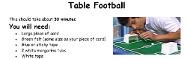  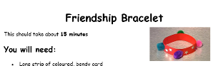  A selection of different instructions including recipes.  Outcome:  Purpose: To instruct  Audience: next year’s year 3 (current year 2)  Form: Instructions – how to create a shadow puppet (link to science earlier in the term)  Viewpoint: 2nd person | Text:  Five Children and IT By E Nesbitt  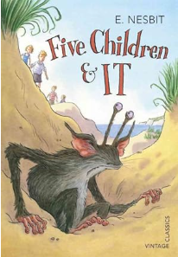  Outcome: Conversation between characters  Purpose: to describe/entertain  Audience: Book readers  Form:  3rd person Story | Text: Horrible Histories Rotten Romans  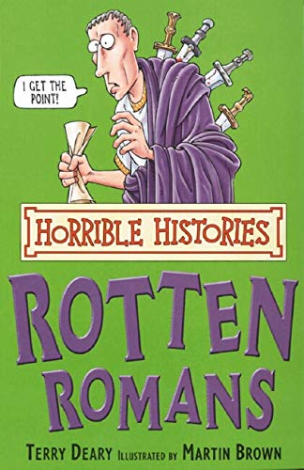  Outcome: Horrible History Mini-guide  Purpose: to inform and entertain  Audience: for the Roman man to share with children  Form: non-chronological report  Viewpoint: 3rd person | 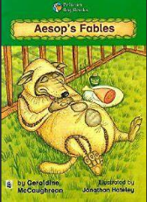  Text: Stories from the Billabong & Aesop’s fables  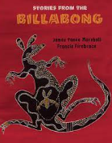  Outcome: to create their own fable for Aesop’s book  Purpose: to entertain  Audience: Aesop  Form: fable  Viewpoint: 3rd person | 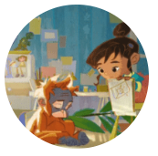  Text: FILM - There’s a rang tan in my bedroom  Outcome: to create their own persuasive advert for Greenpeace to stop deforestation  Purpose: to persuade  Audience: Greenpeace  Form: Advert  Viewpoint: 2nd/3rd person
Learning Journey 3 | Learning Journey 3 | Learning Journey 3 | Learning Journey 3 | Learning Journey 3 | Learning Journey 3
Text:  The Ironman By Ted Hughes  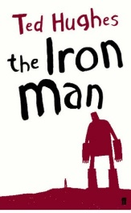  Outcome:  Purpose: To entertain  Audience: The Iron man  Form: Monologue  Viewpoint: 1st person |  | 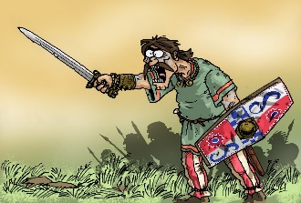  Text: I Smell an Invasion (narrative poem)  Outcome: To write their own narrative poem  Purpose: to entertain  Audience: parents on shelter day  Form: narrative poem  Viewpoint: 1st or 3rd person

