Long term Plan English Year 4
Autumn 1 | Autumn 2 | Spring 1 | Spring 2 | Summer 1 | Summer 2
Learning Journey 1 | Learning Journey 1 | Learning Journey 1 | Learning Journey 1 | Learning Journey 1 | Learning Journey 1
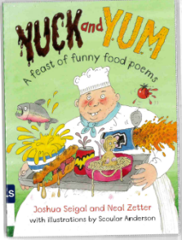  Text: Yuck and Yum: A Feast of Funny Food Poems by Joshua Seigal and Neal Zetter  Outcome: to compose their own food poem in a similar style  Purpose: to entertain  Audience: peers – class poetry book  Form: poem  Viewpoint: 3rd person | 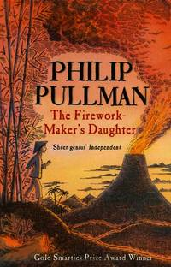  Text: The Firework Maker’s Daughter By Phillip Pullman  Outcome: instructions on how to make an imaginary firework  Purpose: to inform  Audience: other apprentice firework makers  Form: instructions  Viewpoint: 2nd person | Text: Beowulf By Michael Morpurgo  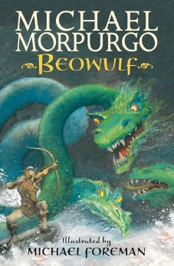  Outcome: Newspaper report about the downfall of Grendel  Purpose: to inform  Audience: Heorot residents  Form: newspaper report  Viewpoint: 3rd person | 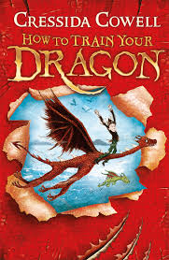  Text: How to Train Your Dragon By Cressida Cowell  Outcome: chapter 2 from an alternative viewpoint  Purpose: to entertain  Audience: parents as part of our art gallery  Form: narrative  Viewpoint: 1st person | 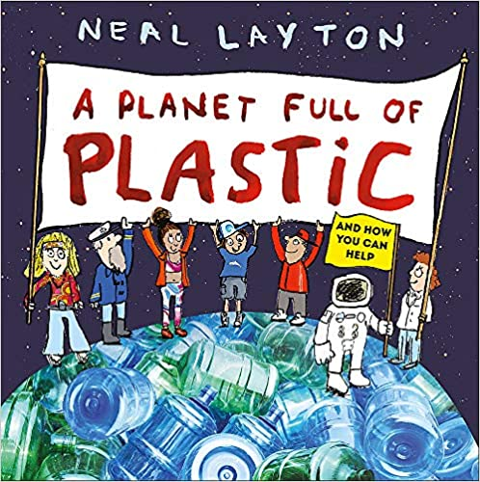  Text: Planet Full Of Plastic By Neil Layton  Outcome: to create leaflets about plastic pollution and how others can help the environment by reducing, reusing and recycling  Purpose: to inform  Audience: parents and peers at the Summer Fair  Form: leaflet  Viewpoint: 2nd and 3rd person | Text:  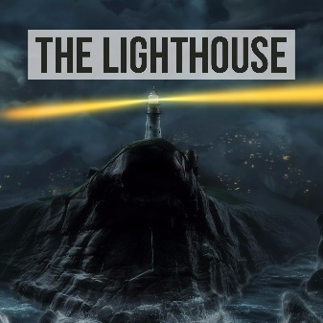  The Lighthouse (Literacy Shed Video)  Outcome: Diary entry written by the Lighthouse keeper about the events from the film  Purpose: to recount/inform  Audience: the lighthouse keeper  Form: diary entry  Viewpoint: 1st person
Learning Journey 2 | Learning Journey 2 | Learning Journey 2 | Learning Journey 2 | Learning Journey 2 | Learning Journey 2
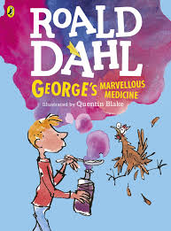  Text: George’s Marvellous Medicine By Roald Dahl  Outcome: to write their own version of a chapter in a similar style – medicine number 5  Purpose: to entertain  Audience: year 5 (to reflect back on their learning from year 4)  Form: narrative - chapter  Viewpoint: 3rd person | Text: Prefabulous Animiles by James Reeves and  Jaberwocky -Lewis Carrol  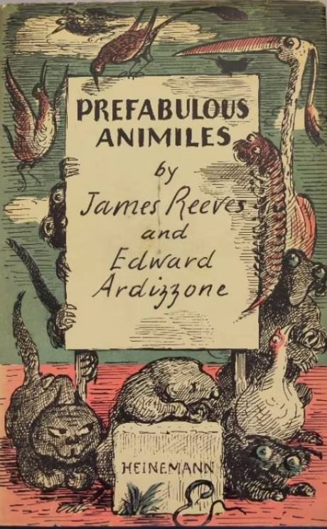  Outcome: An entertaining poem  Purpose: to entertain  Audience: the current year 3’s – save for transition  Form: poetry  Viewpoint: 3rd person | 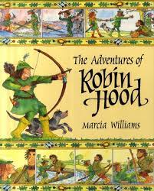  Text: The Adventures of Robin Hood By Mercia Williams  Outcomes: mini-guide to Nottingham Castle  Purpose: to inform and entertain  Audience: family visitors to Nottingham Castle  Form: 1) non-chronological report  2) video recording for Nottingham castle’s website  Viewpoint: 2nd person | 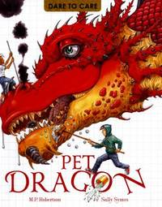  Text: Dare to Care: Pet Dragon By M P Roberson and Sally Symes  Outcome: create own mini-guide of how to care for their dragon  Purpose: to inform  Audience: new dragon owners  Form: dragon care guide book - class  Viewpoint: 2nd and 3rd person | Text: Planet Full Of Plastic By Neil Layton  Outcome: letter to either, Mrs Mullet, Mrs Taylor or The New Forest District Council on suggestions of how the school/council could be more environmentally friendly  Purpose: to persuade  Audience: Mrs Mullet, Mrs Taylor or The New Forest District Council  Form: formal letter  Viewpoint: 1st person | Text: Flotsam By David Wieser  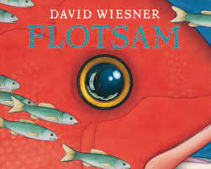  Outcome: eBay advert to sell the camera  Purpose: to persuade  Audience: eBay users who collect unique camera’s  Form: advert  Viewpoint: 2nd person
Learning Journey 3 | Learning Journey 3 | Learning Journey 3 | Learning Journey 3 | Learning Journey 3 | Learning Journey 3
Text: Boy: Tales of Childhood By Roald Dahl  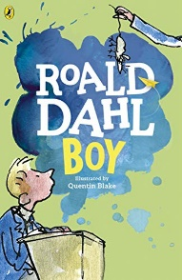  Outcome: My Autobiography all about me!  Purpose: to entertain and inform  Audience: my new class teacher  Form: autobiography  Viewpoint: 1st person | Text: Food reviews various  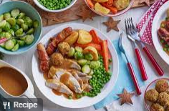  Outcome: A review of Christmas dinner  Purpose: To describe and inform  Audience: Magazine readers  Form: Review  Viewpoint: food critic 1st person

