Long term Plan English Year 6
Autumn 1 | Autumn 2 | Spring 1 | Spring 2 | Summer 1 | Summer 2
Learning Journey 1 | Learning Journey 1 | Learning Journey 1 | Learning Journey 1 | Learning Journey 1 | Learning Journey 1
Text Titanium and Once in a life time (Films)  Outcome: Log book  Purpose to inform  Audience: Pilot  Form: Recount log  View point 1st person | 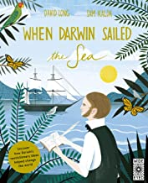  Text: When Darwin Sailed the Sea  Outcome: Biography of Russell Wallace  Purpose: inform  Audience: visitors to search museum Gosport  Form: biography  Viewpoint: 3rd person | 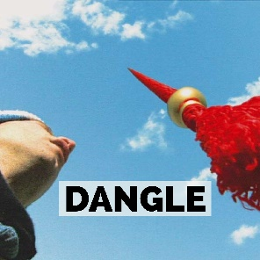  Text: Dangle (Video)  Outcome: Debate and balanced argument – Can the protagonist’s behaviour be justified?  Purpose: to debate  Audience: peers  Form: balanced argument  Viewpoint: 3rd person | 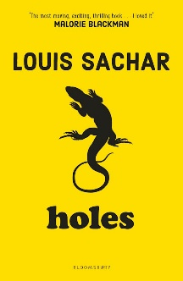  Text: Holes By Louis Sachar  Outcome: Writing in role as Stanley following is arrival at camp Greenlake to his mum  Purpose: to inform and to recount  Audience: Stanley’s mum  Form: informal letter  Viewpoint: 1st person | 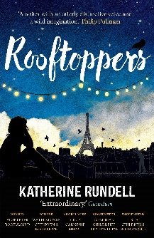  Text: Rooftoppers By Katherine Rundell  Outcome: Report about Charles’ suitability to be a guardian for Sophie  Purpose: to inform  Audience: The National Childcare agency board.  Form: Formal report  Viewpoint: 3rd person | Text: Midsummer Night’s Dream  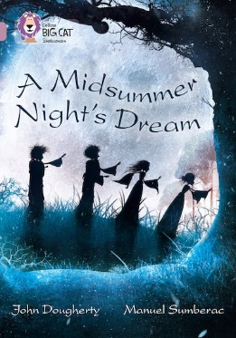  Outcome: Play script  Purpose: to inform  Audience: actors, director and people involved in the play  Form: play script  Viewpoint: 3rd person
Learning Journey 2 | Learning Journey 2 | Learning Journey 2 | Learning Journey 2 | Learning Journey 2 | Learning Journey 2
Text: The true story of the 3 little pigs and The 3 Wolves and the big bad pig  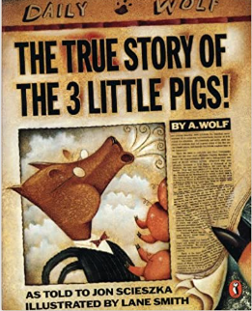  Outcome: Write their own folk tale.  Purpose: entertain  Audience: Children to publish their folk tale to take down to Hythe library for display.  Form: narrative  Viewpoint: 3rd person | Text: Charles Darwin’s on the origin of species  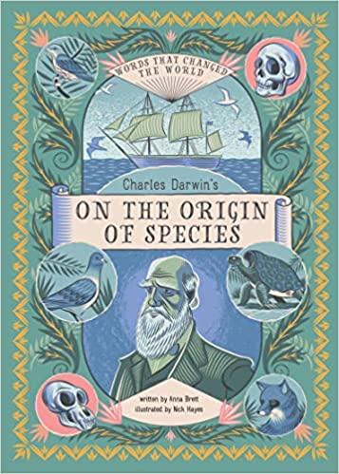  Retold By Sabina Radeva  Outcome: Non-chorological report – to produce a book on newly discovered animals  Purpose: inform  Audience: JK Rowling for inspiration for her new Fantastic beasts books  Form: Non-chorological report  Purpose: inform  Viewpoint: 3rd person | 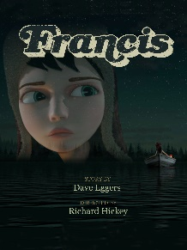  Text: Francis (Literacy Shed Video)  Outcome: To write their own suspense writing  Purpose: to entertain  Audience: Hythe library Halloween display  Form: narrative  Viewpoint: 1st or 3rd person | Text: Holes By Louis Sachar  Outcome: Guide for new residents at Camp Greenlake  Purpose: to inform  Audience: new inmates  Form: non-chronological  Viewpoint: 3rd person | Text: Rooftoppers By Katherine Rundell  Outcome: Diary - Sophie  Purpose: to recount  Audience: Sophie  Form: Diary  Viewpoint: 1st person: | Text: The Lost Worlds By Robert Macfarlane  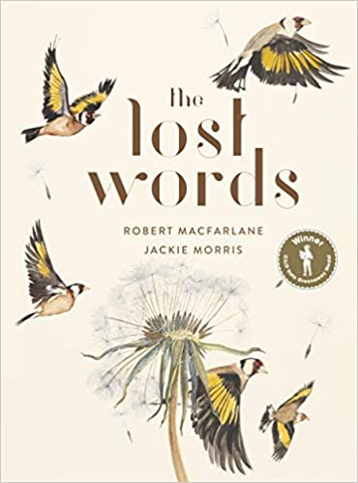  Outcome: Blackout poetry linked to the natural world – poetry book leavers book  Purpose: to entertain  Audience: peers  Form: Poetry  Viewpoint: pupil choice
Learning Journey 3 | Learning Journey 3 | Learning Journey 3 | Learning Journey 3 | Learning Journey 3 | Learning Journey 3
Text: Between Worlds –Kevin Crossly  Outcome: alternative fairy tale – picture book  Purpose: entertain  Audience: year 3 and 4 – story telling opportunity  Form: narrative  Viewpoint: 1st person | Text:  Outcome:  Purpose:  Audience:  Form:  Viewpoint: | 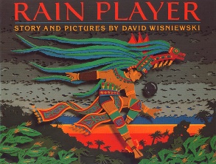  Text: Rain player By Davis Wisniewski  Outcome: Instructions on how to play the Maya game  Purpose: to instruct  Audience: year 5 (play ground game)  Form: Instructions  Viewpoint: 2nd person | Text: Holes By Louis Sachar  Outcome: newspaper report about kissing Kate (outlaw)  Purpose: to inform  Audience: Local residents  Form: Newspaper report  Viewpoint: 3rd person | Text: Rooftoppers By Katherine Rundell  Outcome: letter from Sophie  Purpose: to persuade  Audience: Miss Eliot (The National Childcare Agency)  Form: Formal persuasive letter  Viewpoint: 1st person | Text:  Outcome:  Purpose:  Audience:  Form:  Viewpoint:

