Long term Plan English Year 5
Autumn 1 | Autumn 2 | Spring 1 | Spring 2 | Summer 1 | Summer 2
Learning Journey 1 | Learning Journey 1 | Learning Journey 1 | Learning Journey 1 | Learning Journey 1 | Learning Journey 1
Text: The magic box by Kit Wright  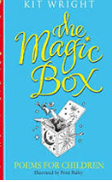  Outcome: Free verse poem  Purpose: entertain  Audience: Create class poetry book  Form: Poem  Viewpoint: First person | Text: Mulan  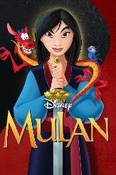  Outcome: Biography on Mulan  Purpose: To inform  Audience: Disney producer  Form: Biography  Viewpoint: 3rd person  Text: Usborne book of | Text- The Phantom Coach -Amelia B Edwards  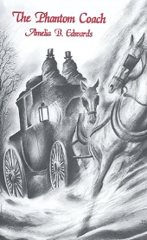  Outcome: Character and setting description  Audience:- Charles Dickens  Form: Chapter starter  Viewpoint: Ist Person. | Text: Usborne book of Greek myths  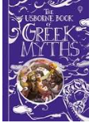  Outcome: Argument persuading Pandora to not open the box  Purpose: Persuasive  Audience: Pandora  Form: Speech  Viewpoint: 1st person | Text: Selection of space poems  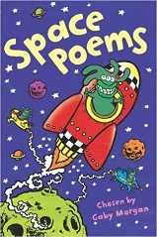  Outcome: Shape space poetry  Purpose: to entertain  Audience: class book  Form: shape poem  Viewpoint: 3rd person/ 1st | Text: The Explorer by Katherine Rundell  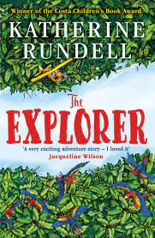  Outcome: setting description to be recorded to support blind people visiting the National Gallery  Purpose: to describe  Audience: RNIB  Form: narrative  Viewpoint: 1st /2nd person
Learning Journey 2 | Learning Journey 2 | Learning Journey 2 | Learning Journey 2 | Learning Journey 2 | Learning Journey 2
Text: The last spell breather by Julie Pike  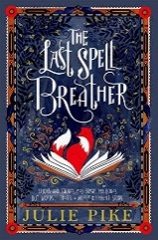  Outcome: Diary entry  Purpose: To inform  Audience: Rayne (writing in role)  Form: Diary  Viewpoint: First person | Text: Mulan  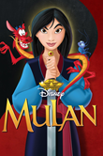  Outcome: Inner monologue to be included in new film version  Purpose: to inform/entertain  Audience: Disney producer  Form: Inner monologue  Viewpoint: 1st person | Text: Yeh Shen  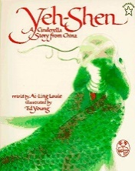  Outcome: Write an alternative ending to Yeh Shen  Purpose: Entertain  Audience:  Form: Narrative  Viewpoint: 3rd person | Text:  Usborne book of Greek myths  Outcome: Fact file of a Greek God/Goddess  Purpose: To inform  Audience: Fact file in History  Form: Non chronological report  Viewpoint: 3rd person | Text: George’s secret key universe by Stephen Hawking  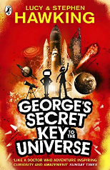  Outcome: Space story opening  Purpose: to entertain  Audience: read to other class  Form: narrative  Viewpoint: 3rd person | Text: The Explorer by Katherine Rundell  Outcome: formal letter to the president of Brazil persuading him to act on deforestation  Purpose: to persuade  Audience: president of Brazil  Form: formal letter  Viewpoint: 1st person
Learning Journey 3 | Learning Journey 3 | Learning Journey 3 | Learning Journey 3 | Learning Journey 3 | Learning Journey 3
Text: The last spell breather by Julie Pike  Outcome: Character description  Purpose: To entertain  Audience: The author Julie Pike  Form: Description  Viewpoint: 3rd person | Text: Dulce et Decorum Est by Wilfred Owen  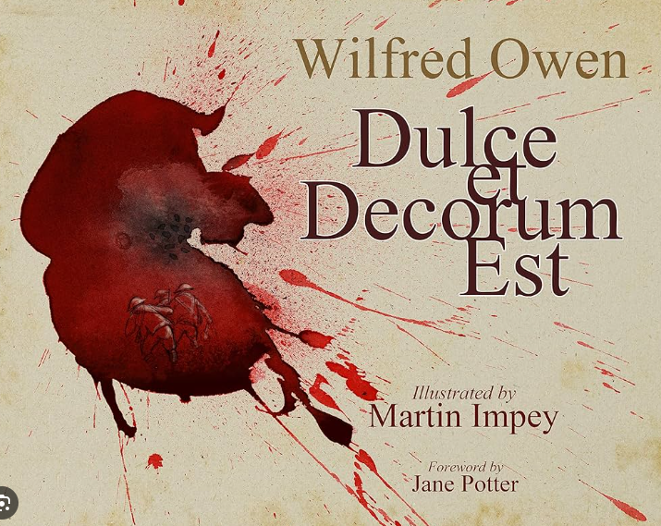  Outcome: Poem  Purpose: to inform/entertain  Audience: Museum  Form: Emotive Poetry | Text: Yeh Shen  Outcome: Newspaper report about the fish being killed by the stepmother  Purpose: inform  Audience: local residents  Form: newspaper report  Viewpoint: 3rd person | Text:  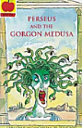  Outcome: Write a radio script to retell part of the Perseus and Medusa story  Purpose: To entertain  Audience: Radio audience  Form: Radio script  Viewpoint: 3rd Person | Text: George’s secret key universe by Stephen Hawking  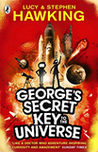  Outcome: leaflet to persuade people to live on a different planet  Purpose: persuade  Audience: people who are space travellers (people currently taking flight with Virgin etc)  Form: leaflet  Viewpoint: 3rd person | Text:  Outcome:  Purpose:  Audience:  Form:  Viewpoint:

